Project Report on

**Project Title**

**Online Bus Seat Reservation System**

Submitted by

**Abhishek Kusalkar [UIT20M1037]**

**Varun Patil [UIT20M1045]**

**Piyush Shinde [UIT20M1057]**

**Jayavant Warkhade [UIT20M1071]**

Under the Guidance of

Prof.Devyani Bhamare

**S. Y. B.Tech**

**[Information Technology]**



**DEPARTMENT OF INFORMATION TECHNOLOGY ENGINEERING**

**SRES's SANJIVANI COLLEGE OF ENGINEERING, KOPARGAON**

**2021-2022**

Sanjivani Rural Education Society’s

**Sanjivani College of Engineering, Kopargaon-423603**

*(An Autonomous Institute Affiliated to Savitribai Phule Pune University, Pune)*

(NAAC ‘A’ Grade Accredited, ISO 9001:2015 Certified)

**Department of Information Technology**

(NBA Accredited)

**CERTIFICATE**



This is to certify that the Project entitled ***“Online Bus Seat Reservation System"*** submitted by

**Abhishek Kusalkar [UIT20M1037]**

**Varun Patil [UIT20M1045]**

**Piyush Shinde [UIT20M1057]**

**Jayavant Warkhade [UIT20M1071]**

is a record of bonafied work carried out by them in partial fulfilment of the requirement of Degree of Bachelor of Technology in Information Technology at Sanjivani College of Engineering, Kopargaon under the University of Pune during academic year 2021-2022

**Devyani Jadhav Dr. M. A. Jawale Dr. A. G. Thakur**

**Project Guide Head of IT Deptt. Director**

Examiner 1: *(Name and Signature)*

Examiner 2: *(Name and Signature)*

**Place**: S.R.E.S’s Sanjivani College of Engineering, Kopargaon

**Date:**

**Acknowledgement**

We would like to acknowledge all the people who have motivated and helped me throughout my dissertation. We are standing on one of the most important steps towards our engineering and we have burnt our fuel, day and night for completing my seminar.

Primarily, We would like to thank my project guide Ms. D. P. Bhamare mam who remained the constant source of information throughout our project Work, his ideas have certainly encouraged me to simplify the difficulties and finalize system.

We are grateful to our H.O.D. Dr. M. A. Jawale Mam and our honorable Director Dr. A.G.Thakur Sir for their consistent guidance. We dedicate this work to our caring parents,without their blessings this would not have been possible. We thank all our friends and non-teaching staff for their valuable time and help for the completion of my seminar.

Once again, We are grateful to all of them without them our seminar would not have been successful

(Students Name & Signature)

**Abstract**

The purpose of Online Bus Ticketing System is to automate the existing manual system by the help of computerized equipment’s and full-fledged computer software, fulfilling their requirements, so that their valuable data/information can be stored for a longer period with easy accessing and manipulation of the same. The required software and hardware are easily available and easy to work with.

Online Bus Ticketing System, as described above, can lead to error free, secure, reliable and fast management system. It can assist the user to concentrate on their other activities rather to concentrate on the record keeping. Thus, it will help organization in better utilization of resources. The organization can maintain computerized records without redundant entries.That means that one need not be distracted by information that is not relevant, while being able to reach the information.

The aim is to automate its existing manual system by the help of computerized equipment and full-fledged computer software, fulfilling their requirements, so that their valuable data/information can be stored for a longer period with easy accessing and manipulation of the same. Basically, the project describes how to manage for good performance and better services for the clients.

**Contents**

|  |  |  |  |  |  |  |  |  |  |  |  |  |  |  |  |  |  |  |  |  |  |  |  |  |  |  |  |  |  |  |  |  |  |  |  |  |  |  |  |  |  |  |  |  |  |  |  |
| --- | --- | --- | --- | --- | --- | --- | --- | --- | --- | --- | --- | --- | --- | --- | --- | --- | --- | --- | --- | --- | --- | --- | --- | --- | --- | --- | --- | --- | --- | --- | --- | --- | --- | --- | --- | --- | --- | --- | --- | --- | --- | --- | --- | --- | --- | --- | --- |
| |  |  |  |  | | --- | --- | --- | --- | | **Sr.** | | **Chapter** | **Page No** | | **1.** |  | **Introduction** |  | |  | 1.1 | Aim and Objective | 06 | |  | 1.2 | Introduction to Project Topi | 07 | |  | 1.3 | Scope of Project | 07 | |  | 1.4 | ER Diagram | 08 | |  | 1.5 | Implementation | 08 | |  | 1.6 | Advantages | 10 | |  | 1.7 | Screenshot of Implementation | 11 | | **2** |  | **Conclusion** | 15 | | **3** |  | **References** | 15 | |  |  |  |
|  |  |  |  |
|  |  |  |  |
|  |  |  |  |
|  |  |  |  |

* 1. **Aim and Objective**

**Aim**

The aim of this project is “To Create Online Bus/Seat Reservation System”

**Objective**

* The software program “Online Bus Reservation System” provides bus transportation system, a facility to**reserved seats, cancellation of seats and different types of enquiry which need an instant and quick reservation**. OBTRS is built for manage and computerize the traditional database, ticket booking and tracking bus and travel made easy.
* We feel some drawbacks of offline bus reservation system so to overcome this we build Online Bus Reservation System.
* The main objective of the Project on Online Bus Ticketing System is to manage the details of Bus, Route, City, Booking, Customer. It manages all the information about Bus, Registration, Customer, Bus. The purpose of the project is to build an application program to reduce the manual work for managing the Bus, Route, Registration, City. It tracks all the details about the city, Booking, Customer.
  1. **Introduction**

The "Online Bus Booking System" has been developed to override the problems prevailing in the practicing manual system. This software is supported to eliminate and, in some cases, reduce the hardships faced by this existing system. Moreover, this system is designed for the particular need of the company to carry out operations in a smooth and effective manner.

The application is reduced as much as possible to avoid errors while entering the data. It also provides error message while entering invalid data. No formal knowledge is needed for the user to use this system. Thus, by this all it proves it is user-friendly. Online Bus Ticketing System, as described above, can lead to error free, secure, reliable and fast management system. It can assist the user to concentrate on their other activities rather to concentrate on the record keeping. Thus, it will help organization in better utilization of resources.

Every organization, whether big or small, has challenges to overcome and managing the information of Route, Bus, Booking, Registration, Customer. Every Online Bus Ticketing System has different Bus needs, therefore we design exclusive employee management systems that are adapted to your managerial requirements. This is designed to assist in strategic planning, and will help you ensure that your organization is equipped with the right level of information and details for your future goals. Also, for those busy executive who are always on the go, our systems come with remote access features, which will allow you to manage your workforce anytime, at all times. These systems will ultimately allow you to better manage resources.

* 1. **Scope of Project**

It may help collecting perfect management in details. In a very short time, the collection will be obvious, simple and sensible. It will help a person to know the management of passed year perfectly and vividly. It also helps in current all works relative to Online Bus Ticketing System. It will be also reduced the cost of collecting the management & collection procedure will go on smoothly. Our project aims at Business process automation, i.e. we have tried to computerize various processes of Online Bus Ticketing System.

* In computer system the person has to fill the various forms & number of copies of the forms can be easily generated at a time.
* In computer system, it is not necessary to create the manifest but we can directly print it, which saves our time.
* To assist the staff in capturing the effort spent on their respective working areas.
* To utilize resources in an efficient manner by increasing their productivity through automation.
* The system generates types of information that can be used for various purposes.
* It satisfies the user requirement
* Be easy to understand by the user and operator
* Be easy to operate
* Have a good user interface
* Be expandable
* Delivered on schedule within the budget.
  1. **ER Diagram**

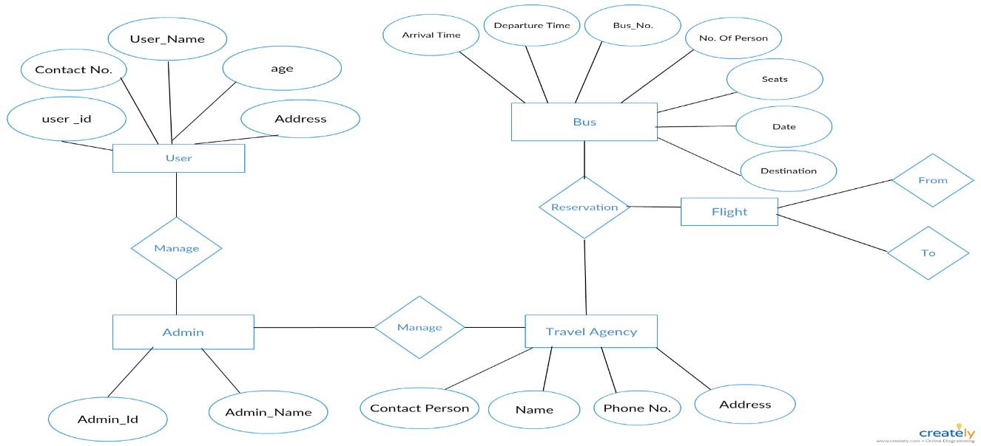



* 1. **Implementation**

For any project to be completed, it has to go through stages called Development Life Cycles. System Development Life Cycle (SDLC) is the process of understanding how an Information System (IS) can support business needs, designing the system, building it and delivering it to users. The SDLC composes of four phases: Planning, Analysis, Design and Implementation.

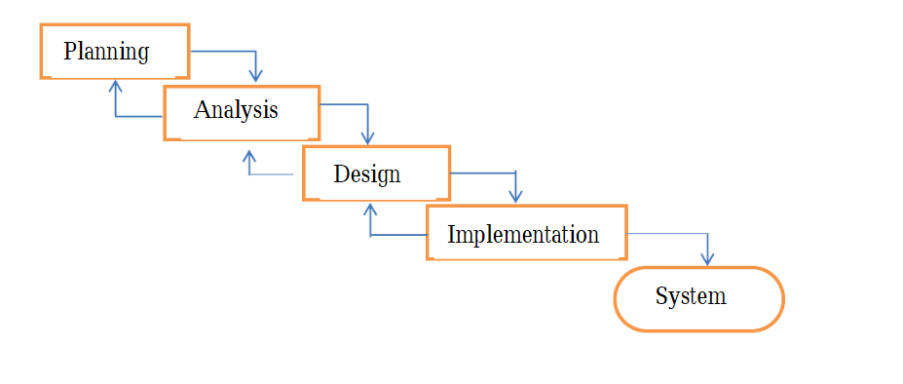

**Implementation is Done In Two Ways**

**1)Without GUI**

* CSV module and user defined module imported

**2)With GUI**

* modules Imported -

1. Tkinter :- Tkinter is Python's de-facto standard GUI (Graphical User Interface) package. It is a thin object-oriented layer on top of Tcl/Tk. Tkinter is not the only Gui Programming toolkit for Python. It is however the most commonly used one.
2. Random :- In this project we used random to generate bus Number .
3. Time:- used to generate time while registration .
4. Datetime:- used to take date from system and provide to receipt function.
5. Sqlite3:- used to store login id and password.

**Functional Requirements For Without GUI**

* Bus Company Name
* Bus contact Number
* Bus Address
* Departure
* Destination
* Date and Day
* Passenger name
* No of passenger
* Seat no
* Bus Type(AC/Non AC)
* Boarding point address
* Total fare
* Departure time

**Functional Requirements For With GUI**

1. **For Accessing:**
2. Login ID and Password
3. **For Performing:**

* FirstName
* Surname
* Address
* Postcode
* Telephone
* Mobile
* Email
* Bus Type
* Ticket Side
* Pickup
* Drop
* TAX
* Luggege
* Insurance
* Distance
* Subtotal
* total

**Project Structure & File Names**

1. **Without GUI**

* Passengerinfo.py
* TicketShow.py
* Admin.py
* main.py

1. **With GUI**

* Index.py

**Classes Used In Project**

* **ClassName = PassengerRegistration**

**Attribute in class**

* passengerName
* noOfPassenger
* departureLocation
* destinationLocation
* selectDay
* selectSeatNo
* selectBusType
* busFare
* autoInc
* countCol
* **Class Name = PassengerDataCsv**
* Here we will save the data on csv file permanently
* **Class Name = TicketShow**
* After Booking we can check the ticket
* **Class Name = Admin**
  1. **Advantages**
  + Reporting & Charting in more comprehensive way
  + User Accounts to control the access and maintain security
  + Simple Status & Resolutions
  + Multi-level Priorities & Severities.
  + Attachments & Additional Comments for more information
  + Accuracy in work.
  + Easy & fast retrieval of information.
  + Decrease the load of the person involve in existing manual system.
  + Access of any information individually.
  + Work becomes very speedy.
  + Easy to update information

**Using Without GUI Screenshots**

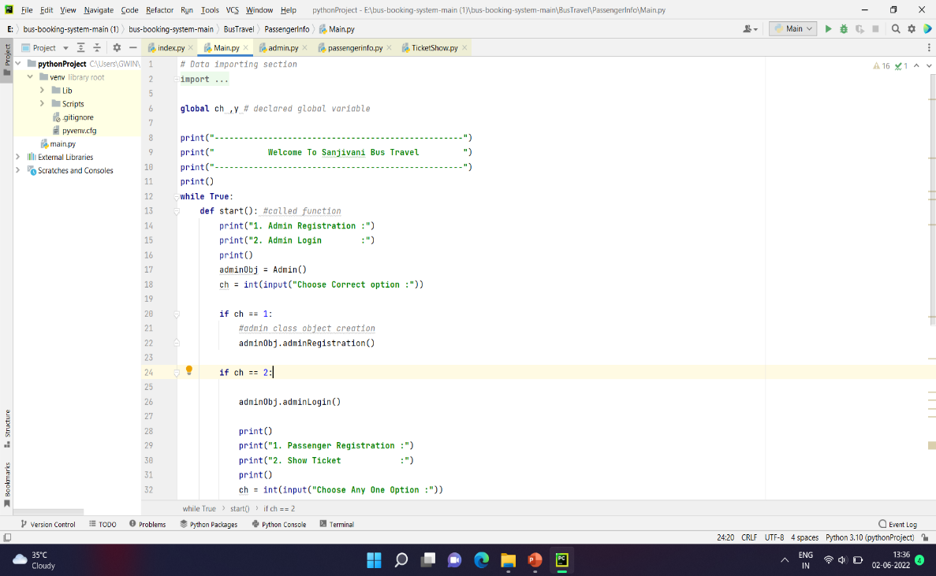

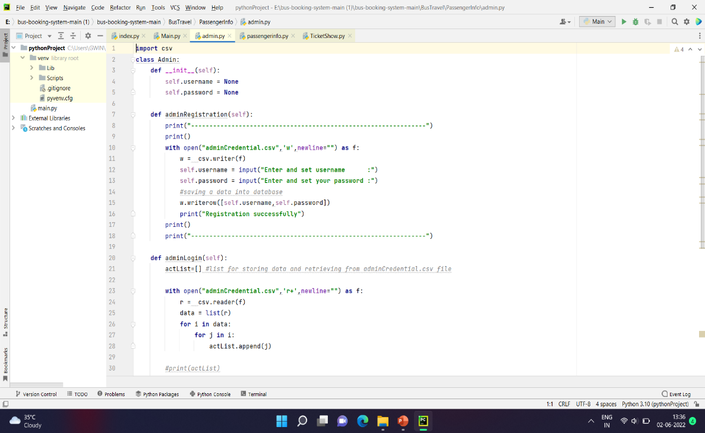

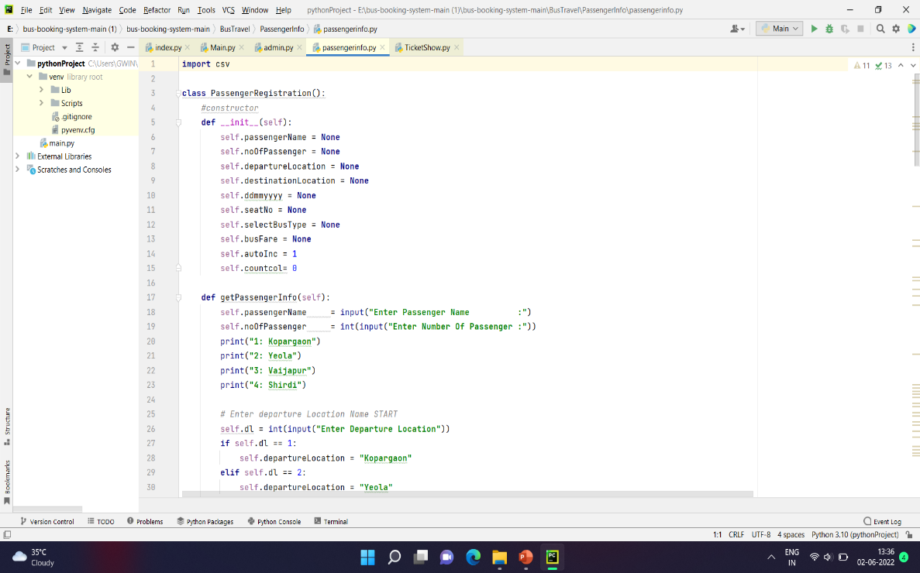

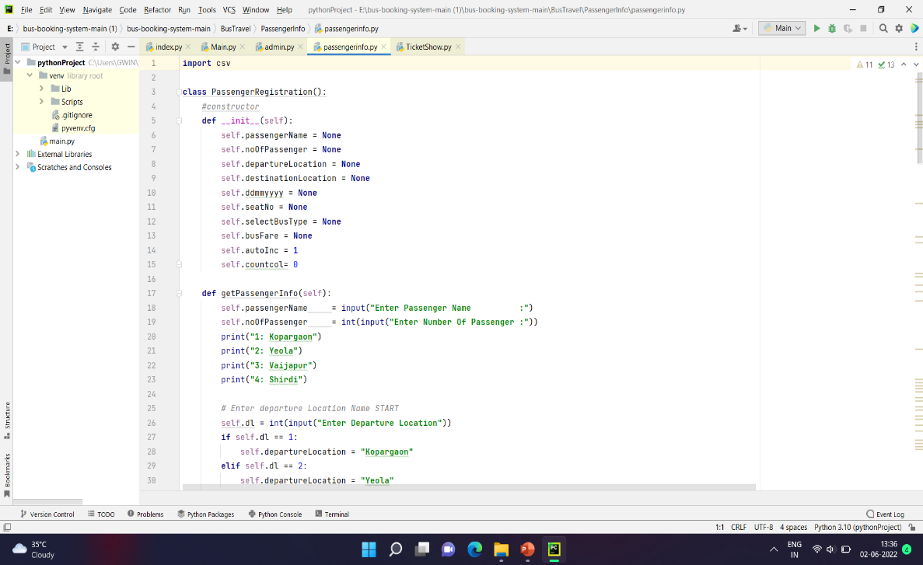

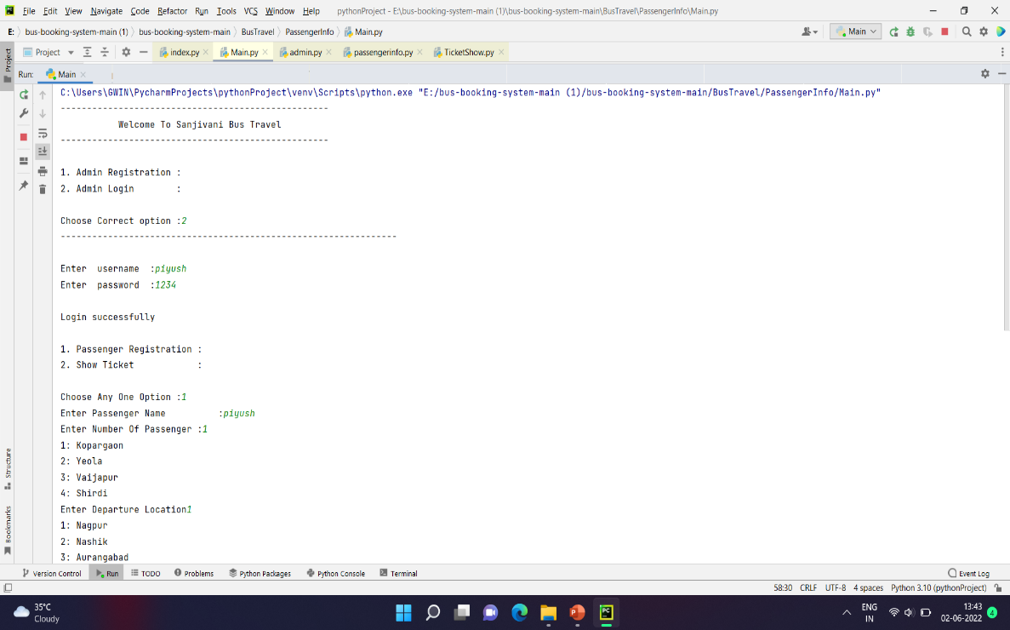

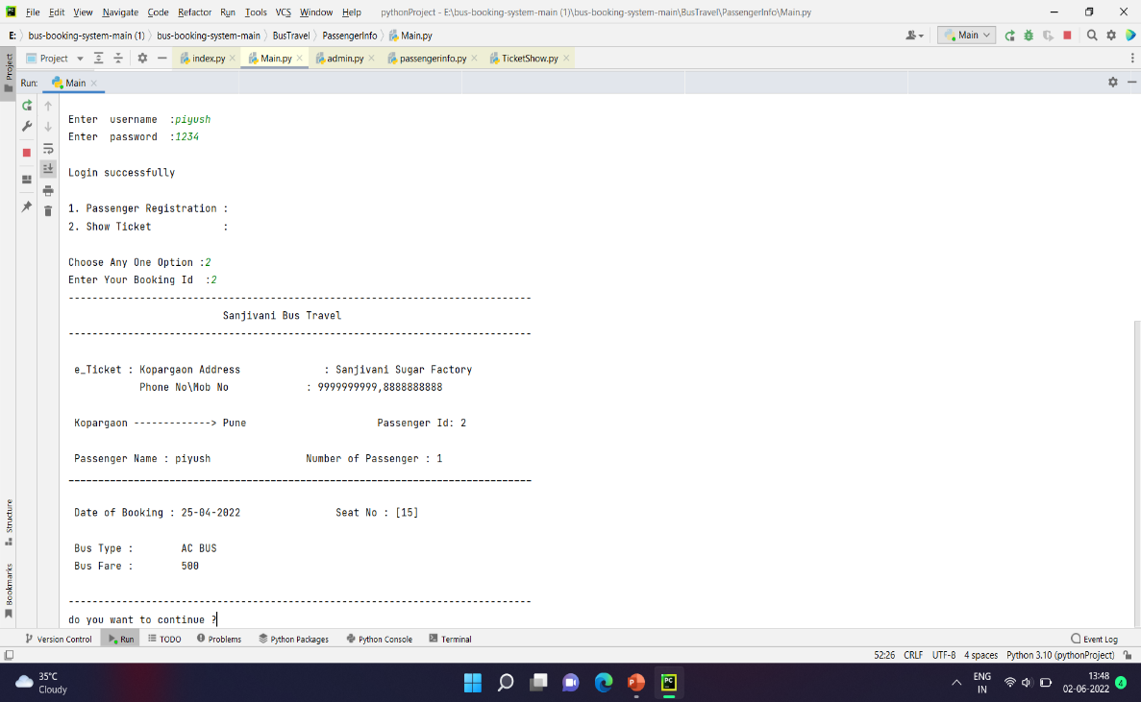

**CSV Files**

**Using GUI Screenshots**

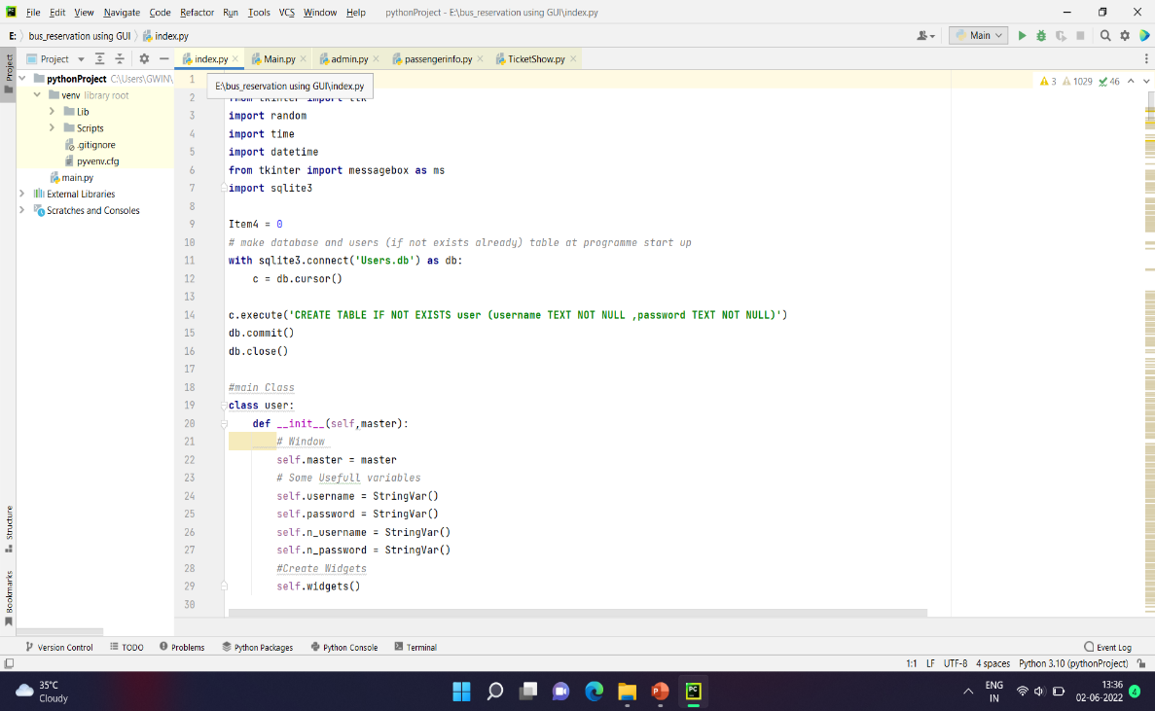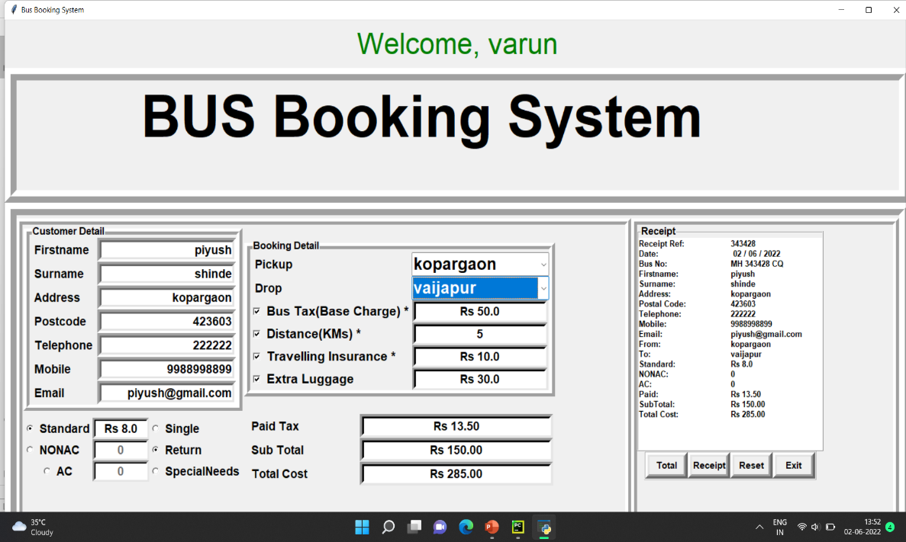

**CONCLUSION**

* By Implementing Online bus reservation system, we reduce the manual job to check ticket of each passenger, book a ticket physically, no case of loss of ticket.
* Just require Id and Password to Check ticket and Book ticket.
* Can Access Data At any Time anywhere.
* Not require to bring print of ticket.

**REFERENCES**

* [**(PDF) Online Bus Ticket Reservation System (researchgate.net)**](https://www.researchgate.net/publication/326468848_Online_Bus_Ticket_Reservation_System)
* [**https://www.geeksforgeeks.org/how-to-install-a-python-module/**](https://www.geeksforgeeks.org/how-to-install-a-python-module/)
* [**https://ascendixtech.com/online-bus-ticket-booking-reservation-system-development/**](https://ascendixtech.com/online-bus-ticket-booking-reservation-system-development/)
* [**https://www.geeksforgeeks.org/python-gui-tkinter/**](https://www.geeksforgeeks.org/python-gui-tkinter/)
* [**https://www.datascienceexamples.com/csv-file-reading-without-pandas/**](https://www.datascienceexamples.com/csv-file-reading-without-pandas/)
* [**https://www.w3schools.com/python/python_modules.asp**](https://www.w3schools.com/python/python_modules.asp)
* [**https://www.youtube.com/watch?v=8lkyOGUhK8Q**](https://www.youtube.com/watch?v=8lkyOGUhK8Q)
* [**https://techvidvan.com/tutorials/modules-in-python/**](https://techvidvan.com/tutorials/modules-in-python/)
* [**https://www.w3schools.com/python/python_functions.asp**](https://www.w3schools.com/python/python_functions.asp)
* [**https://www.geeksforgeeks.org/loops-in-python/**](https://www.geeksforgeeks.org/loops-in-python/)
* [**https://www.codespeedy.com/python-program-for-login-page-using-tkinter-package/#:~:text=1st%20of%20all%20in%20the,1st%20import%20the%20Tkinter%20package.&text=Create%20a%20function%20which%20generates,login%20page%20as%20a%20title**](https://www.codespeedy.com/python-program-for-login-page-using-tkinter-package/#:~:text=1st%20of%20all%20in%20the,1st%20import%20the%20Tkinter%20package.&text=Create%20a%20function%20which%20generates,login%20page%20as%20a%20title)**.**